Journal of Structural Engineering, Vol.71B, April 2025 Architectural Institute of Japan

構造工学論文集Vol.71B (2025年4月) 日本建築学会

BUCKLING MECHANISM OF LATTICED CYLINDRICAL ROOF SHELLS AND THE APPLICATION FOR DESIGN

Sub title

*Hajime KOUZOU * Fumiko KANKYO ** and Saburo KEIKAKU \*\**

In this paper, the buckling mechanism of latticed cylindrical shells and the application for design procedure have been discussed. The effects of geometric and boundary restrict induced imperfections have first been demonstrated. Then the reduced stiffness buckling analytical concept has been introduced and the simple lower bound estimation equation through the so-called continuum shell analogy theory has been proposed. The linear and nonlinear buckling loads by the conventional finite element analyses have also been compared with the present estimations. Finally how to apply the elastic buckling load estimation to elastic-plastic buckling load carrying capacity has been represented.

***Keywords*:***Lattice shell, Buckling, Imperfection, Cylindrical shell, buckling load carrying capacity, Buckling mode*

**1．INTRODUCTION**

It is expected that authors will submit carefully written and proofread material. Spelling and grammatical errors, as well as language usage problems, are not acceptable. The paper length should not exceed 14 pages. Papers should clearly describe the background of the subject, the authors work, including the methods used, and concluding discussion on the importance of the work. Papers are to be prepared in English (British or American) and SI-units shall be used.

**2．PAPER FORMAT**

**2.1 Fonts and format to be used**

Fonts, sizes and spacing should be used as they are used in this document. The layout of page size is A4.

Body text should be written in Times New Roman 8 pt. It is recommended that the captions of figures and tables should be written in bold 8pt and lettering used in figures and tables should be no smaller than 8pt.

**2.2 Graphics and tables**

Create graphs and line drawings electronically, and insert them electronically into the finished document. Photographs should also be inserted electronically in

|  |  |  |  |
| --- | --- | --- | --- |
|  | * | Prof., Dept of Architecture, Taishinkozo University. Dr. Eng. |  |
|  | ** | Student, Dept of Civil Eng., Kensetu University |  |

to the document. Figure captions and table headings should be sufficient to explain the figure or table without needing to refer to the text. Figures and tables not cited in the text should not be presented.

The following is the example for Table 1.

**Table 1 Comparison with previous data**

|  |  |  |  |
| --- | --- | --- | --- |
|  | Present | Previous Data | |
| Plate | Shell |
| Result | 3.03 | 3.10 | 3.05 |

Here is an example for Fig.1.

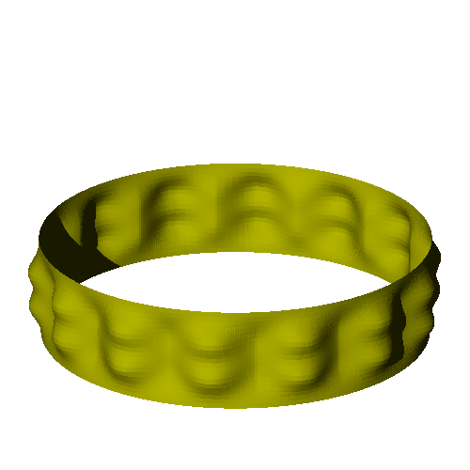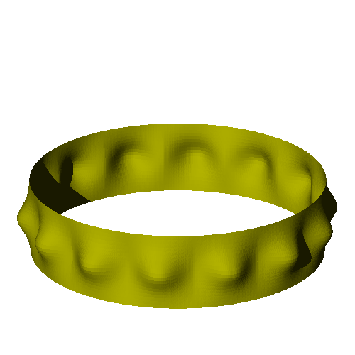

1.0

0

0

1

2

3

**



*W* mm

0.5

**Fig.1 Load versus deflection curves for imperfect cylinders**

**2.3 Equations**

Insert all equations using the equation editor, as text if possible, or as an image. Equations should be clear and all symbols should be explained within the text of your manuscript. The equations should be numbered as shown in Eq. (1) below.



(1)

Heading of reference section is not to be numbered, and one blank line below the heading. No blank line is set between the references. The references should be presented completely and without mistakes, and should be the original publication. In-text citations should be designated as for example, Ref.2. The references should be listed in the same order as cited in the text.

**REFERENCES**

1. B.G.Falzon and M.H.Aliabadi: *Buckling and Postbuckling Structures*, Imperial College Press, 2008.5.
2. S.Yamada, K.Uchiyama and M.Yamada: Experimental investigation of the buckling of shallow spherical shells, *International Journal of Non-Linear Mechanics*, Vol.18, No.1, pp.37-54, 1983.8.
3. S.Yamada and J.G.A.Croll: Elasto-plastic buckling design for shallow cylindrical shells under external pressure, *IASS-ASCE International Symposium*, ASCE, pp. 936-945, 1994.4.